Sprint 2 Report
Last Revised:
(October 23, 2025 - November 4, 2025)

SlugConnect
Elian - product owner (e.g. product owner / developer)
Sam - Scrum Master
Tyler - Developer
Neha - Developer
Dean - Developer
Actions to Stop Doing
- The team must stop delaying making progress and make sure to put in consistent amounts of work each day and keep up with the daily scrum meetings.
Actions to Start Doing
- Start meeting throughout the week at times that we can all be there (scrum meetings). Dedicate time to ensure that user stories are met, and reach out to the team and/or Kat for questions or when issues arise.

Actions to Keep Doing
- Keep communicating in the group chat or discord about what needs to be worked on in order to ensure that we’re meeting the deadlines and ensuring everyone stays on track. Keep managing time so that we can obtain an MVP (we got this team).

Work Completed / Not Completed
- Completed:
  - Pages setup: Sign-In page, Sign-Up page, Auth Page, Onboarding page, and Discover page.
  - Front End Design schema
  - Database schema
- Not Completed:
  - Setting up front end points to back end points
  - “Skeleton” for the web application
  - Edit profile functionality
  - Ability to see other user profiles with common interests

Work Completion Rate
- 79.5%
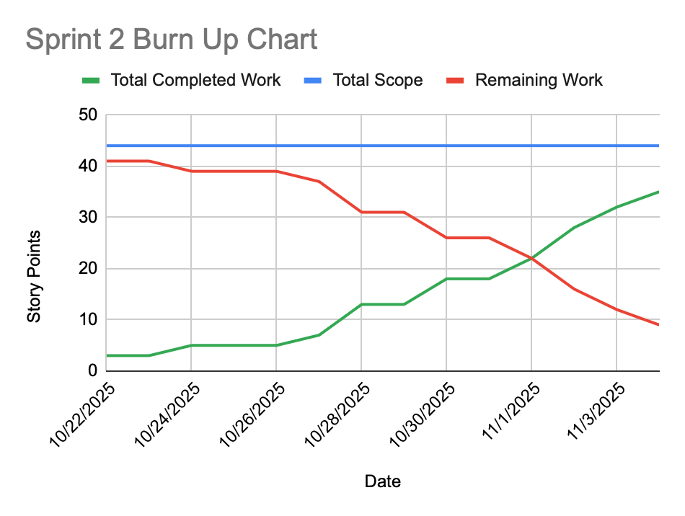
(Full Burn Up Chart spreadsheet is linked to graph)

